For my ME 310 project, I am working on doing finite element analysis on sheep bone healing mechanics. For ME 310 I am looking at creating 2D models from high resolution x-rays taken during the healing process. As the sheep progress through the healing cycle, the bone gets stronger. Modeling can be done to quantitatively determine how strong the bone is. For ME 310 I hope to create simple finite element models for over 30 sheep x-rays.

My MECH 312 project proposal is a build-off of this.

A paper by Dr. Comiskey proposes that you can predict the callus zone for a healing element computationally. This can be done by creating 2D plane strain finite element models of fracture zones, and measuring the strain field. A figure is shown below which shows what type of bone material forms under different hydrostatic and distortional strain values.

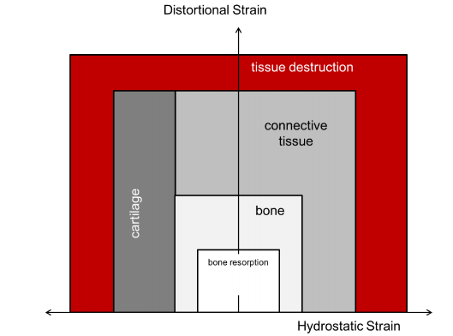

Figure 1 – Bone material vs. hydrostatic and distortional strain

For MECH 312, I would like to do the opposite of what Dr. Comiskey did. I would like to provide an estimate of the external forces applied to the bone based on the callus formation seen the x-ray. This will be done using an iterative method of the finite element analysis, where you can ignore tissue which is outside of the strain field. Dr. Comiskey got pretty good results form 4 iterations, so I would expect that this should also get me pretty good results for the forces experienced by the bone.